Project Report
Student ID: cy2668, yy5028, zl5604
Name: Chenghao Yang, Yihua Yang, Ziyi Liang
Course: CS-GY 6083 Principles of Database System
Section Number: B
Date of Submission: Dec 8, 2024

Table of Contents
- Execute Summary
- Logical and Relational Models
- Technology Stacks
- SQLite DDL Files
- Tables
- Screenshots
- Security Features
- Lesson Learned
- Business Analysis

Execute Summary
NICE (Nature International Cruise Excellence) is a distinguished cruise line renowned for delivering exceptional cruise experiences across 35 ports spanning the USA, Canada, Mexico, and the Caribbean islands. The company offers a comprehensive array of luxurious amenities, diverse entertainment options, and customizable packages designed to meet the varied needs of its clientele. Given the extensive network of ports and a global customer base, implementing a robust full-stack solution is essential to effectively serve both customers and staff. Such a solution is typically composed of three integral components: a responsive and user-friendly web-based front-end interface, a scalable and efficient backend powered by a modern framework, and a meticulously designed database management system to ensure seamless data storage, retrieval, and analysis.
A user-friendly interface enhances customer experience, enabling real-time bookings, package customization, and access to cruise details. This drives customer engagement and boosts sales.
A scalable backend ensures efficient data processing, seamless integration with payment systems, and automation of business rules like group bookings and age-based pricing. This reduces operational errors and enhances system reliability.
A robust database centralizes customer, trip, and payment data, supporting efficient storage, retrieval, and reporting. This empowers data-driven decision-making, ensures consistency, and enables scalability as NICE expands.

Logical and Relational Models

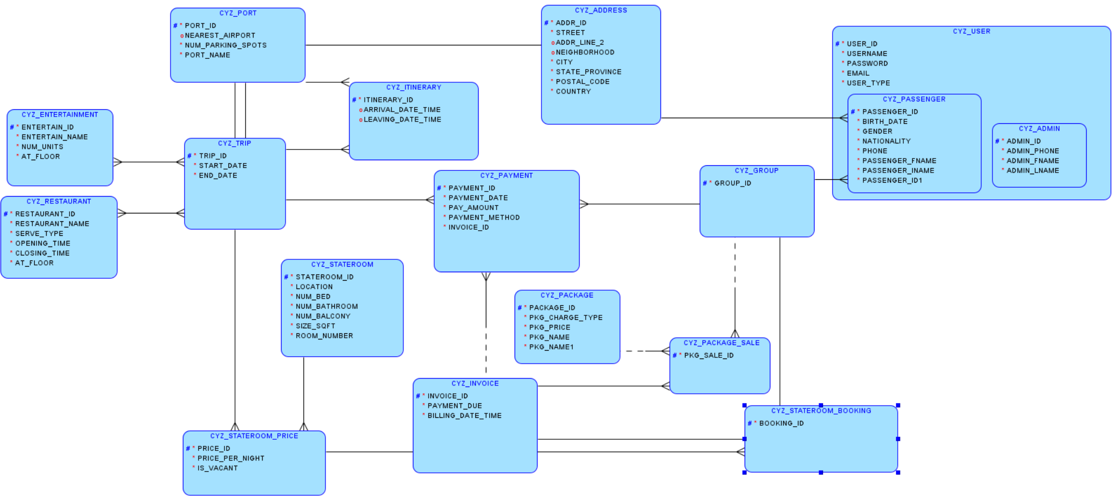
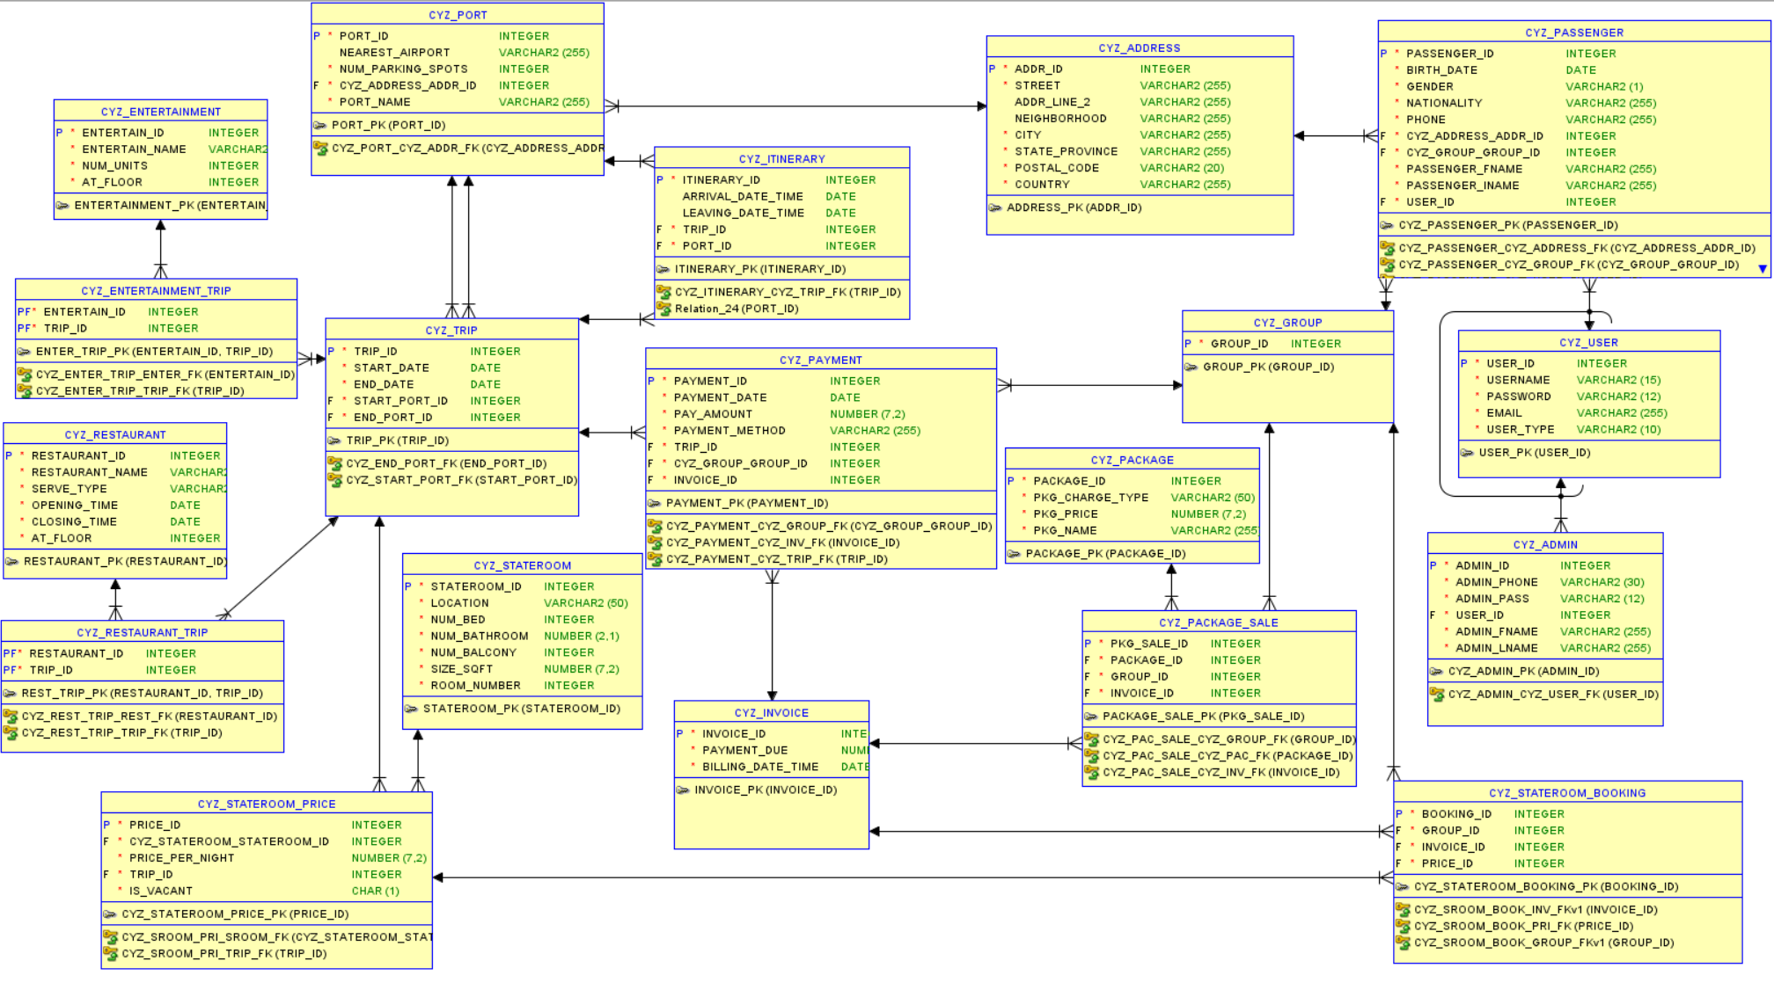
To ensure a well-structured logical and relational model, several key assumptions have been established:
Group and Trip Association: Each group is exclusively associated with a single trip, while a trip may accommodate multiple groups.
Room Booking and Package Sales: Room bookings and package purchases are linked to groups. Each passenger within a group may book a stateroom or purchase packages, provided they meet the age requirements.
Payment and Invoice Association: Payments are tied to groups, and each invoice may have multiple associated payments. Passengers within a group have the ability to view invoices, make payments, and review payment details.
Dynamic Pricing for Staterooms: Stateroom pricing is trip-specific, enabling NICE to adjust prices based on factors such as travel seasons or off-seasons.
Trip-Specific Amenities: Availability of entertainment facilities and restaurants may vary depending on the specific trip, accommodating seasonal and operational differences.
User Account Requirement: All individuals are required to register a user account before booking staterooms or purchasing packages, ensuring secure and organized data management.
These assumptions form the foundation of a logical and relational model that aligns with business requirements while providing the flexibility needed for operational efficiency.

Technology Stacks

Software
To streamline prototyping and debugging for both the front-end and back-end development, we utilized tools such as Visual Studio Code and GitHub. For front-end development, we employed the Vite build tool and the Vue.js framework, along with Node.js for package management. On the backend, we used Oracle Data Modeler and SQLite3 to design and manage the database, while Postman was employed to test API responses and ensure backend functionality.

Programming Language
The front end was developed using JavaScript, Vite, and Vue.js, while the backend was implemented with Python and the Flask framework.

Database
SQLite was chosen as the database management system due to its lightweight architecture and ease of use, making it an ideal choice for rapid development and deployment during the project.

SQLite DDL Files
CREATE TABLE cyz_address (
addr_id INTEGER PRIMARY KEY,
street TEXT NOT NULL,
addr_line_2 TEXT,
neighborhood TEXT,
city TEXT NOT NULL,
state_province TEXT NOT NULL,
postal_code TEXT NOT NULL,
country TEXT NOT NULL
);

CREATE TABLE cyz_admin (
admin_id INTEGER PRIMARY KEY,
admin_phone TEXT NOT NULL,
user_id INTEGER NOT NULL,
admin_fname TEXT NOT NULL,
admin_lname TEXT NOT NULL,
FOREIGN KEY ( user_id ) REFERENCES cyz_user ( user_id )
);

CREATE TABLE cyz_entertainment (
entertain_id INTEGER PRIMARY KEY,
entertain_name TEXT NOT NULL,
num_units INTEGER NOT NULL,
at_floor INTEGER NOT NULL
);

CREATE TABLE cyz_entertainment_trip (
entertain_id INTEGER NOT NULL,
trip_id INTEGER NOT NULL,
PRIMARY KEY ( entertain_id, trip_id ),
FOREIGN KEY ( entertain_id ) REFERENCES cyz_entertainment ( entertain_id ),
FOREIGN KEY ( trip_id ) REFERENCES cyz_trip ( trip_id )
);

CREATE TABLE cyz_group (
group_id INTEGER PRIMARY KEY
);

CREATE TABLE cyz_invoice (
invoice_id INTEGER PRIMARY KEY,
payment_due REAL NOT NULL,
billing_date_time INTEGER NOT NULL
);

CREATE TABLE cyz_itinerary (
itinerary_id INTEGER PRIMARY KEY,
arrival_date_time INTEGER,
leaving_date_time INTEGER,
trip_id INTEGER,
port_id INTEGER,
FOREIGN KEY (trip_id) REFERENCES cyz_trip (trip_id),
FOREIGN KEY (port_id) REFERENCES cyz_port (port_id)
);

CREATE TABLE cyz_package (
package_id INTEGER PRIMARY KEY,
pkg_charge_type TEXT CHECK (pkg_charge_type IN ('per night', 'per trip')) NOT NULL,
pkg_price INTEGER NOT NULL,
pkg_name TEXT NOT NULL
);

CREATE TABLE cyz_package_sale (
pkg_sale_id INTEGER PRIMARY KEY,
package_id INTEGER NOT NULL,
group_id INTEGER NOT NULL,
invoice_id INTEGER NOT NULL,
FOREIGN KEY (package_id) REFERENCES cyz_package (package_id),
FOREIGN KEY (group_id) REFERENCES cyz_group (group_id),
FOREIGN KEY (invoice_id) REFERENCES cyz_invoice (invoice_id)
);

CREATE TABLE cyz_passenger (
passenger_id INTEGER PRIMARY KEY,
birth_date INTEGER NOT NULL,
gender TEXT CHECK (gender IN ('female', 'male', 'other')) NOT NULL, -- Female male or other
nationality TEXT NOT NULL,
phone TEXT NOT NULL,
addr_id INTEGER,
group_id INTEGER NOT NULL, -- Debatable whether this should be NOT NULL
passenger_fname TEXT NOT NULL,
passenger_lname TEXT NOT NULL,
user_id INTEGER NOT NULL,
FOREIGN KEY (addr_id) REFERENCES cyz_address (addr_id),
FOREIGN KEY (group_id) REFERENCES cyz_group (group_id),
FOREIGN KEY (user_id) REFERENCES cyz_user (user_id)
);

CREATE TABLE cyz_payment (
payment_id INTEGER PRIMARY KEY,
payment_date INTEGER NOT NULL,
pay_amount REAL NOT NULL,
payment_method TEXT NOT NULL,
trip_id INTEGER NOT NULL,
group_id INTEGER NOT NULL,
invoice_id INTEGER NOT NULL,
FOREIGN KEY (trip_id) REFERENCES cyz_trip (trip_id),
FOREIGN KEY (group_id) REFERENCES cyz_group (group_id),
FOREIGN KEY (invoice_id) REFERENCES cyz_invoice (invoice_id)
);

CREATE TABLE cyz_port (
port_id INTEGER PRIMARY KEY,
nearest_airport TEXT,
num_parking_spots INTEGER CHECK(num_parking_spots >= 0) NOT NULL,
addr_id INTEGER NOT NULL,
port_name TEXT NOT NULL,
FOREIGN KEY (addr_id) REFERENCES cyz_address (addr_id)
);

CREATE TABLE cyz_restaurant (
restaurant_id INTEGER PRIMARY KEY,
restaurant_name TEXT NOT NULL,
serve_type TEXT NOT NULL,
opening_time TEXT NOT NULL,
closing_time TEXT NOT NULL,
at_floor INTEGER NOT NULL
);

CREATE TABLE cyz_restaurant_trip (
restaurant_id INTEGER NOT NULL,
trip_id INTEGER NOT NULL,
PRIMARY KEY (restaurant_id, trip_id),
FOREIGN KEY (restaurant_id) REFERENCES cyz_restaurant (restaurant_id),
FOREIGN KEY (trip_id) REFERENCES cyz_trip (trip_id)
);

CREATE TABLE cyz_stateroom (
stateroom_id INTEGER PRIMARY KEY,
stateroom_type TEXT NOT NULL,
location TEXT CHECK (location IN ('forward', 'aft', 'left', 'right')) NOT NULL,
num_bed INTEGER CHECK (num_bed >= 0) NOT NULL,
num_bathroom INTEGER CHECK (num_bathroom >= 0) NOT NULL,
num_balcony INTEGER CHECK (num_balcony >= 0) NOT NULL,
size_sqft REAL NOT NULL,
room_number INTEGER NOT NULL
);

CREATE TABLE cyz_stateroom_booking (
booking_id INTEGER PRIMARY KEY,
group_id INTEGER NOT NULL,
invoice_id INTEGER NOT NULL,
price_id INTEGER NOT NULL,
FOREIGN KEY (group_id) REFERENCES cyz_group (group_id),
FOREIGN KEY (invoice_id) REFERENCES cyz_invoice (invoice_id),
FOREIGN KEY (price_id) REFERENCES cyz_stateroom_price (price_id)
);

CREATE TABLE cyz_stateroom_price (
price_id INTEGER PRIMARY KEY,
stateroom_id INTEGER NOT NULL,
price_per_night REAL NOT NULL,
trip_id INTEGER NOT NULL,
is_vacant BOOLEAN NOT NULL,
FOREIGN KEY (stateroom_id) REFERENCES cyz_stateroom (stateroom_id),
FOREIGN KEY (trip_id) REFERENCES cyz_trip (trip_id)
);

CREATE TABLE cyz_trip (
trip_id INTEGER PRIMARY KEY,
start_date INTEGER NOT NULL,
end_date INTEGER NOT NULL,
start_port_id INTEGER NOT NULL,
end_port_id INTEGER NOT NULL,
FOREIGN KEY (start_port_id) REFERENCES cyz_port (port_id),
FOREIGN KEY (end_port_id) REFERENCES cyz_port (port_id)
);

CREATE TABLE cyz_user (
user_id INTEGER PRIMARY KEY,
username TEXT NOT NULL UNIQUE,
password TEXT NOT NULL,
email TEXT NOT NULL UNIQUE,
user_type TEXT CHECK ( user_type IN ( 'admin', 'passenger' ) ) NOT NULL
);

Tables
Combining with Python scripts and SQLite queries

import sqlite3

conn = sqlite3.connect(cruise.db')
cursor = conn.cursor()

cursor.execute("SELECT name FROM sqlite_master WHERE type='table';")
tables = cursor.fetchall()

print("Table Name | Total Records")
for table in tables:
table_name = table[0]
cursor.execute(f"SELECT COUNT(*) FROM {table_name};")
count = cursor.fetchone()[0]
print(f"{table_name} | {count}")

conn.close()

we can show the list of tables and the total number of records of each table:
cyz_address | 10
cyz_admin | 2
cyz_entertainment | 17
cyz_entertainment_trip | 34
cyz_group | 2
cyz_invoice | 3
cyz_itinerary | 10
cyz_package | 5
cyz_package_sale | 1
cyz_passenger | 4
cyz_payment | 3
cyz_port | 5
cyz_restaurant | 9
cyz_restaurant_trip | 18
cyz_stateroom | 28
cyz_stateroom_booking | 2
cyz_stateroom_price | 56
cyz_trip | 2
cyz_user | 6

Screenshots
The homepage
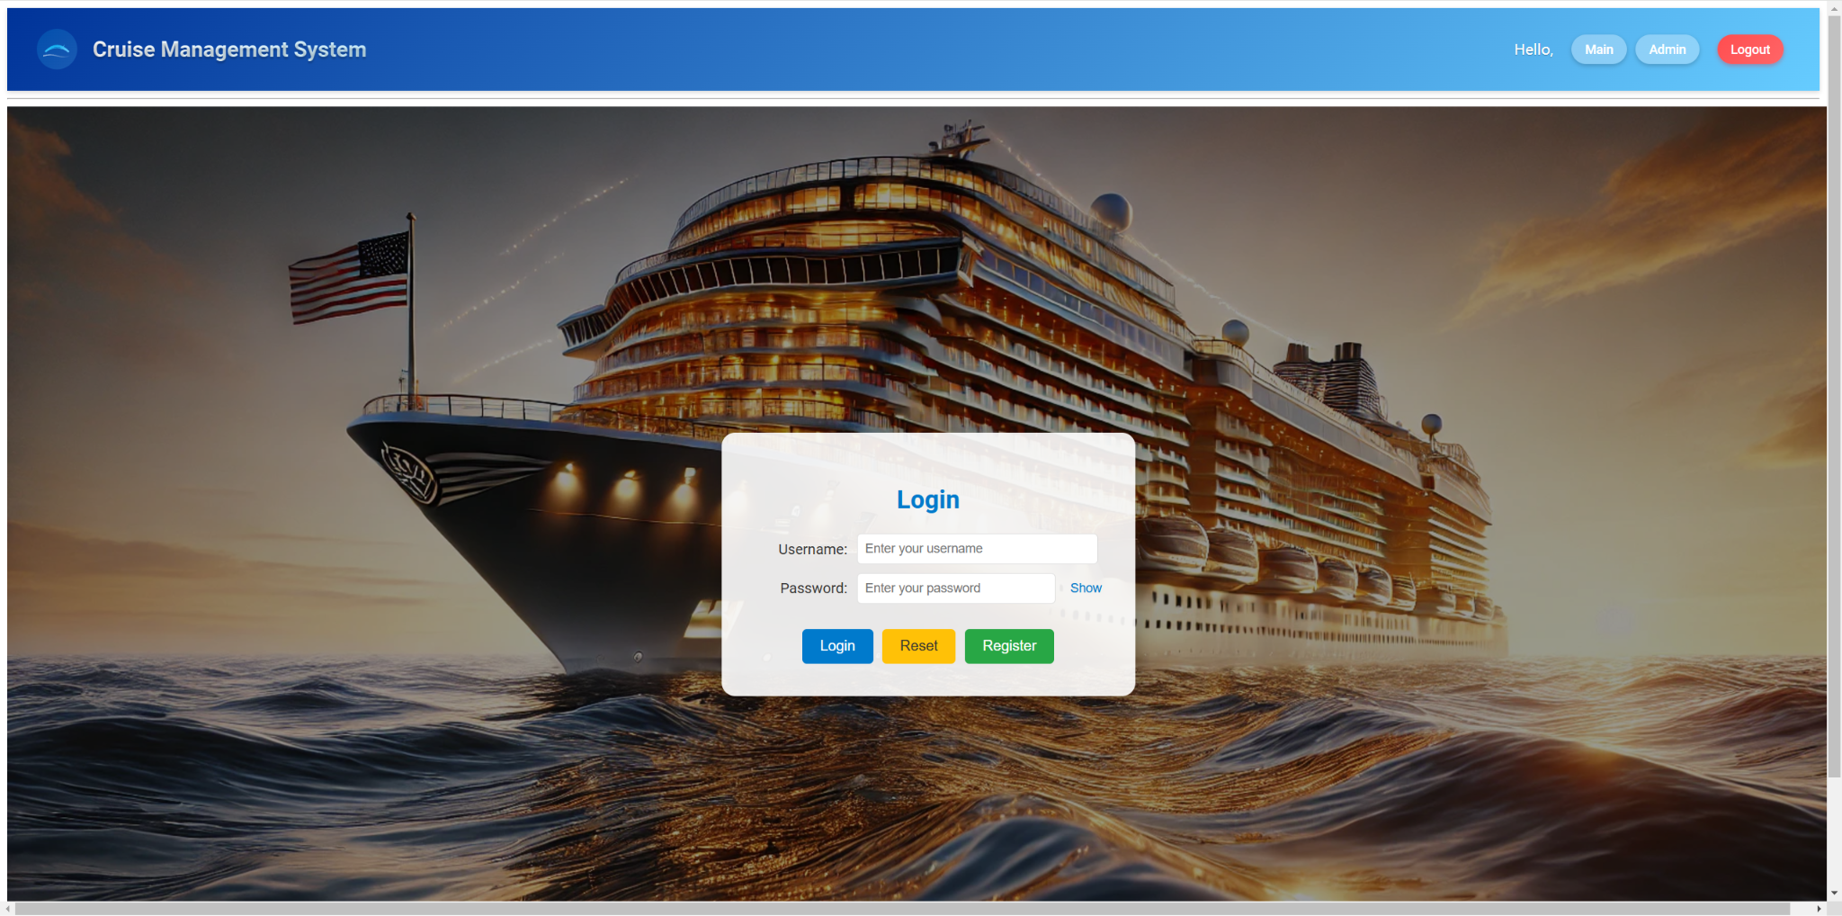
Upon login, the user will be redirected to the dashboard page if they log in as passengers.
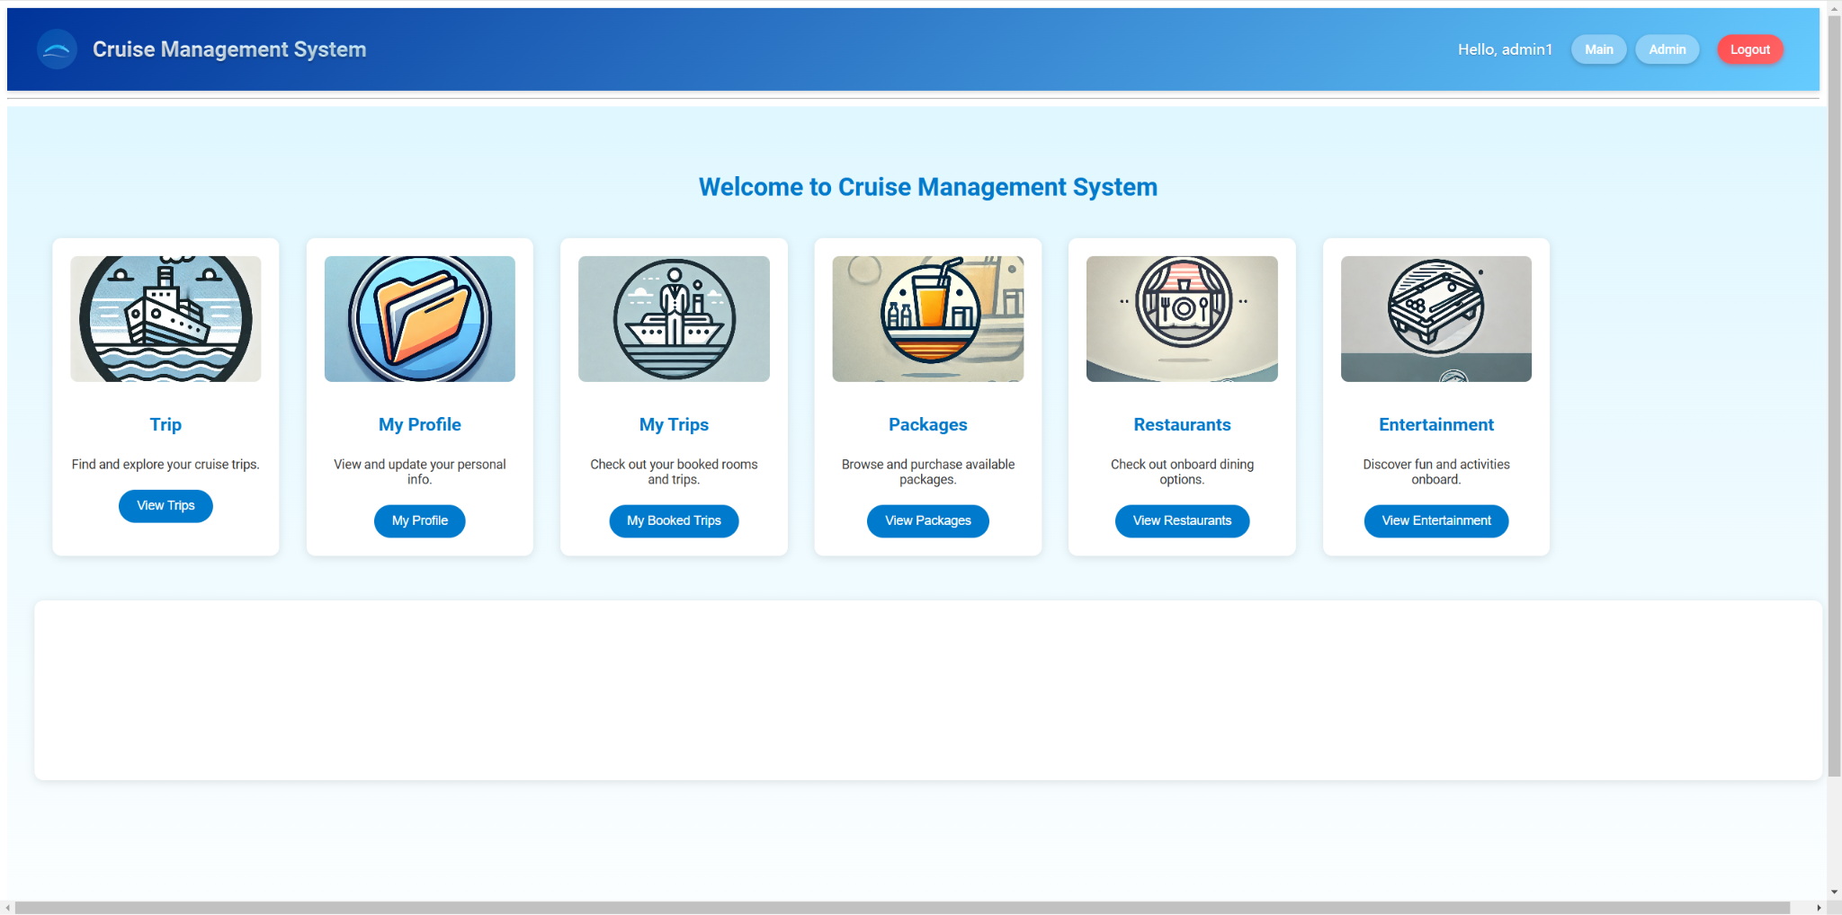
By clicking on Trip, the user can search trip by date:
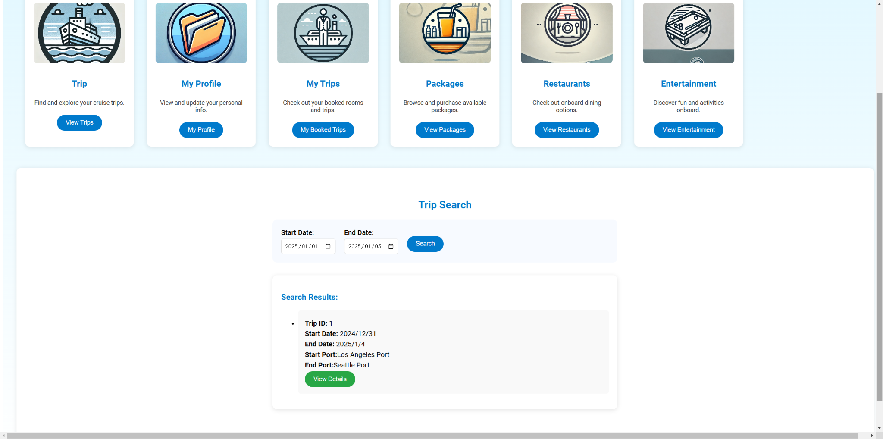
By clicking on My Profile, the user can view or update their profile details:
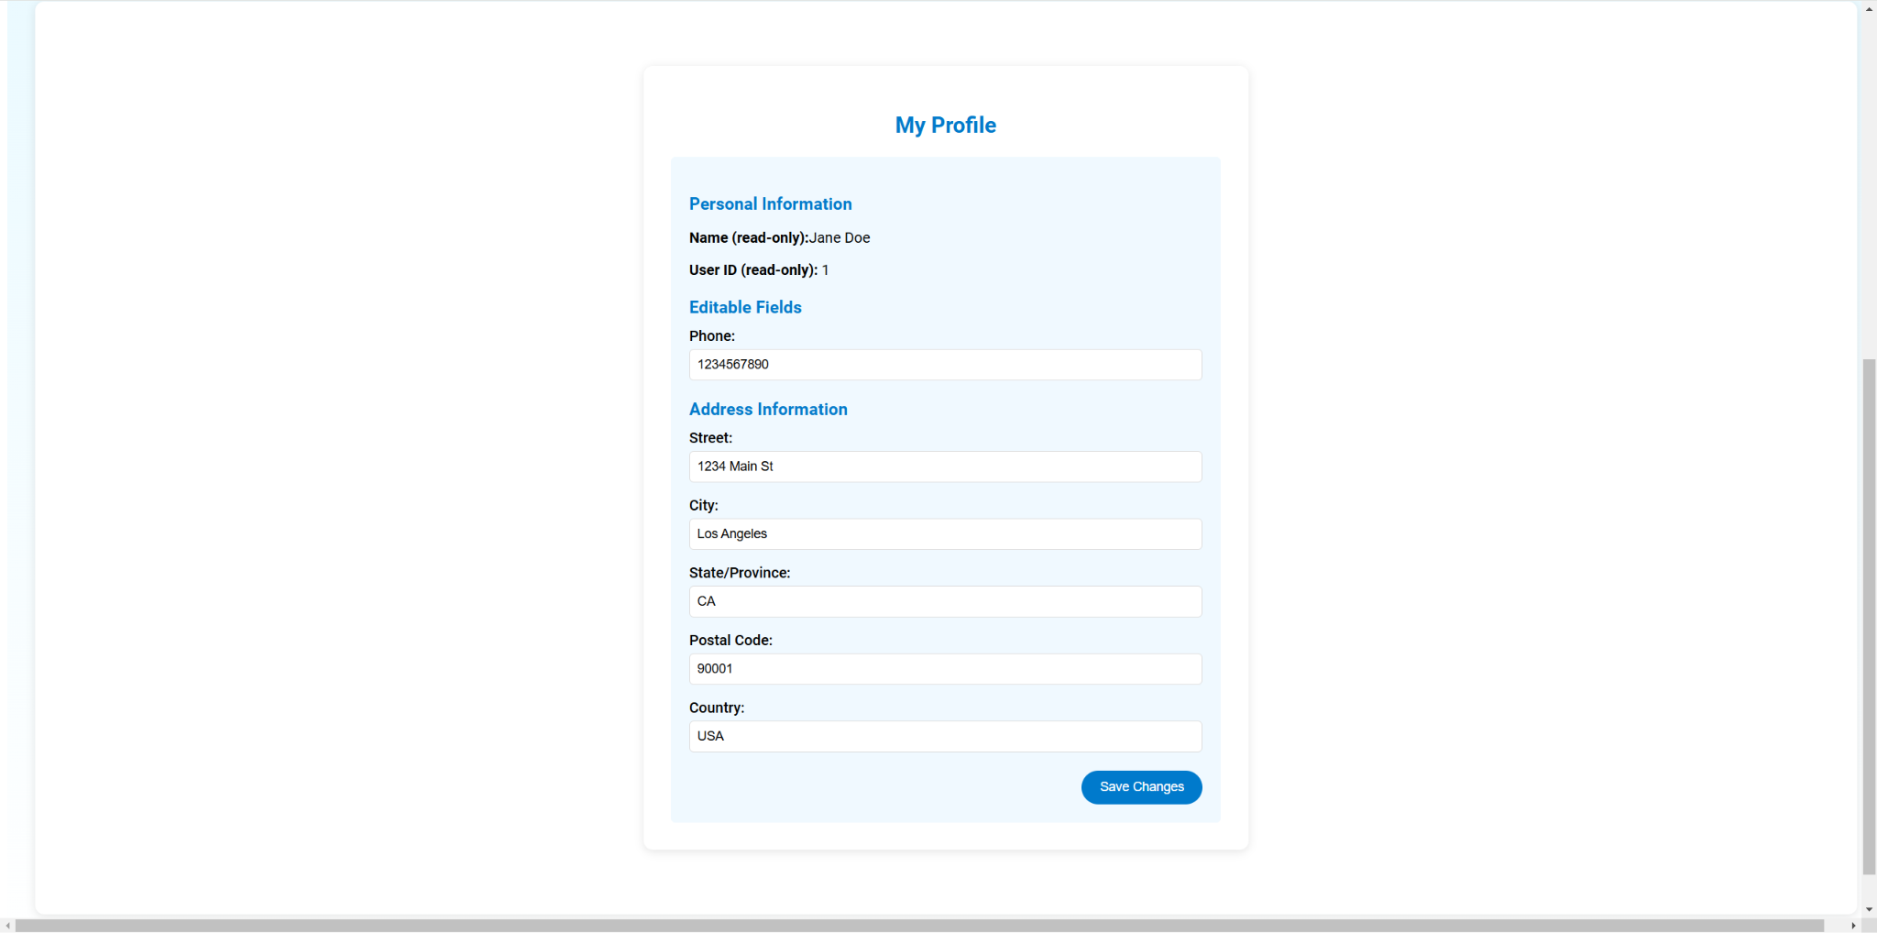
By clicking on Packages, the user can view the available packages:
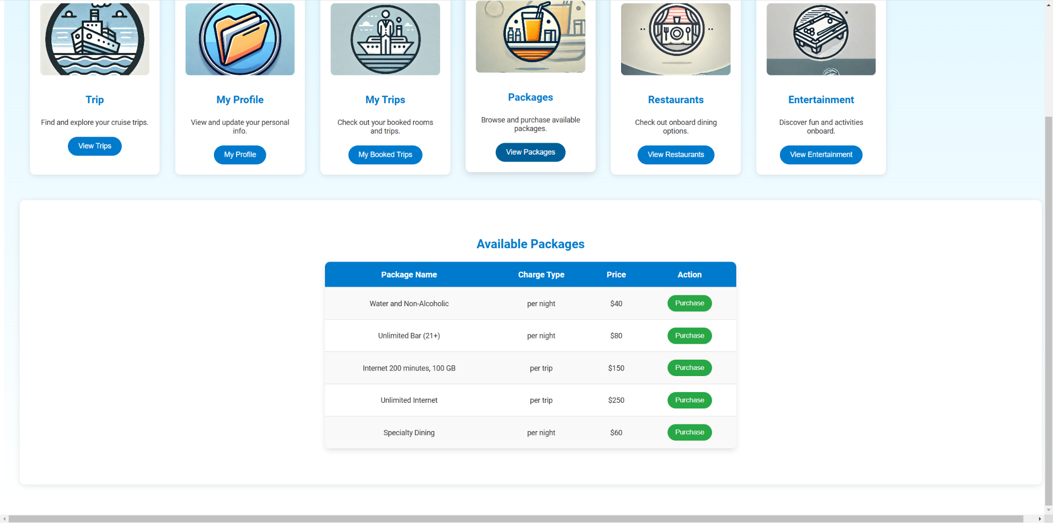
By clicking any available package, the user can review order and make a purchase:
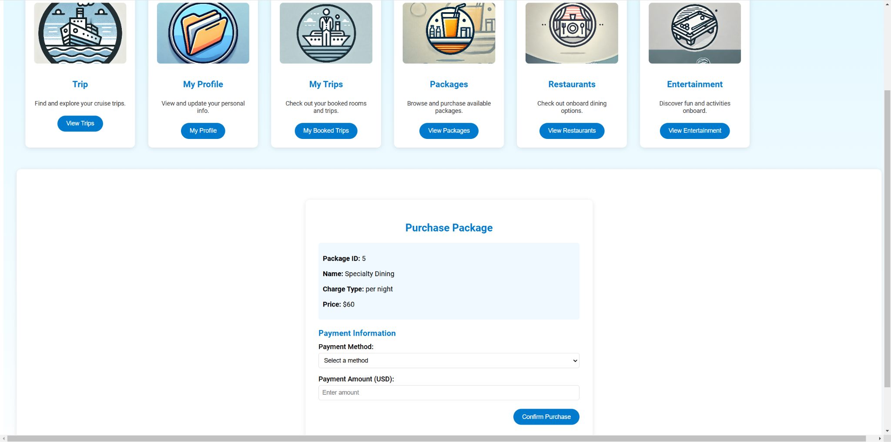
By clicking on Entertainment, the u ser can see the available entertainment facilities on board:
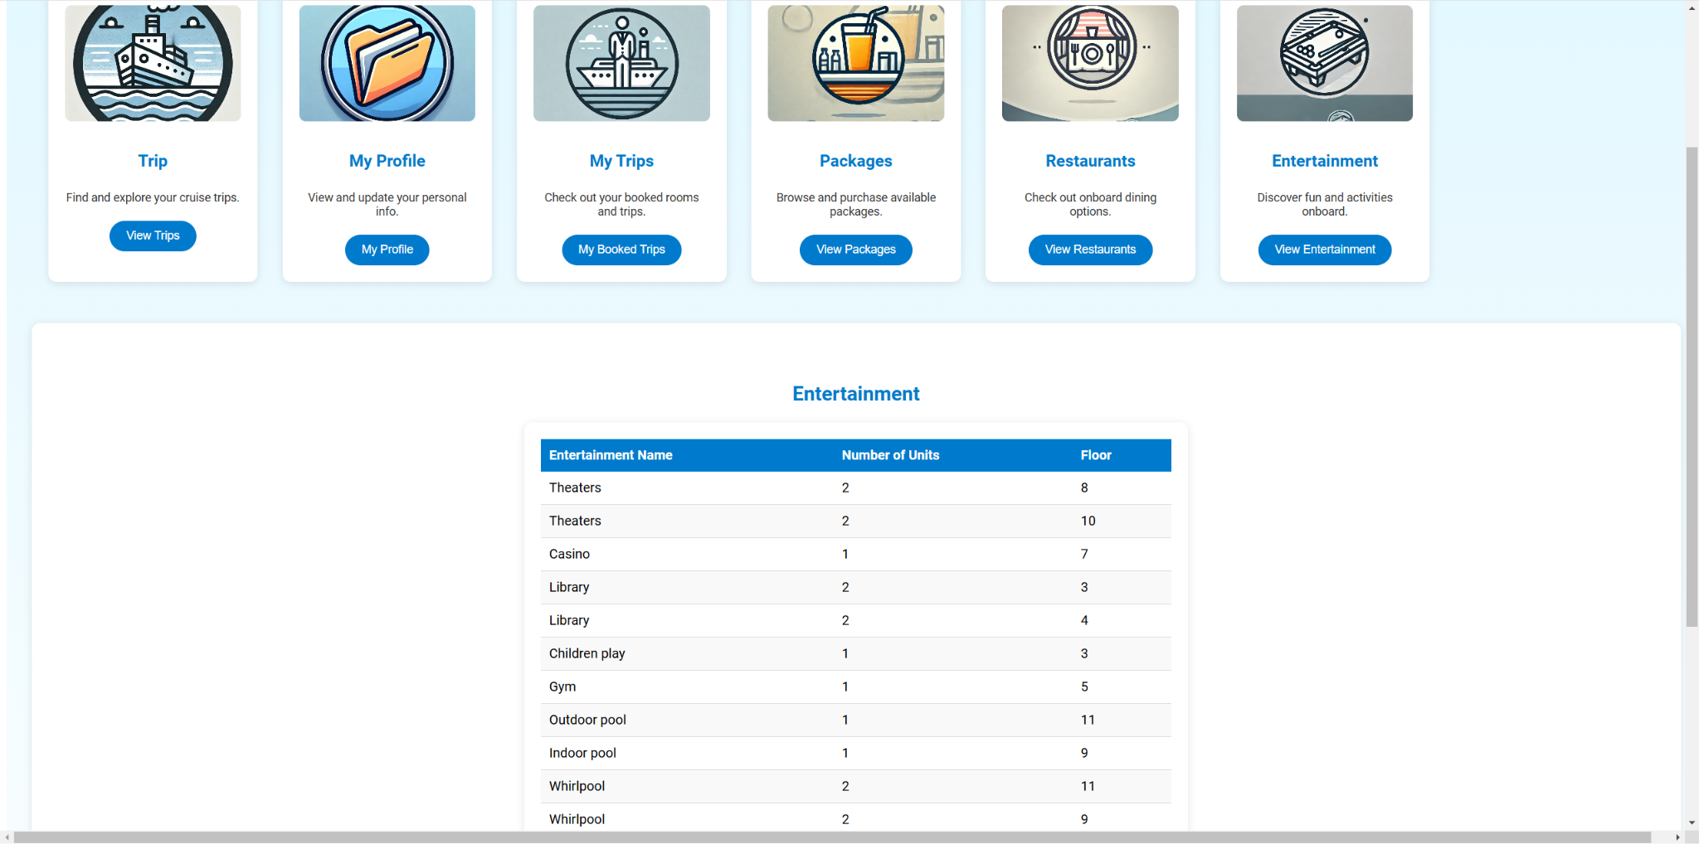
If the user logs in as an administrator, they will be redirected to the Admin dashboard
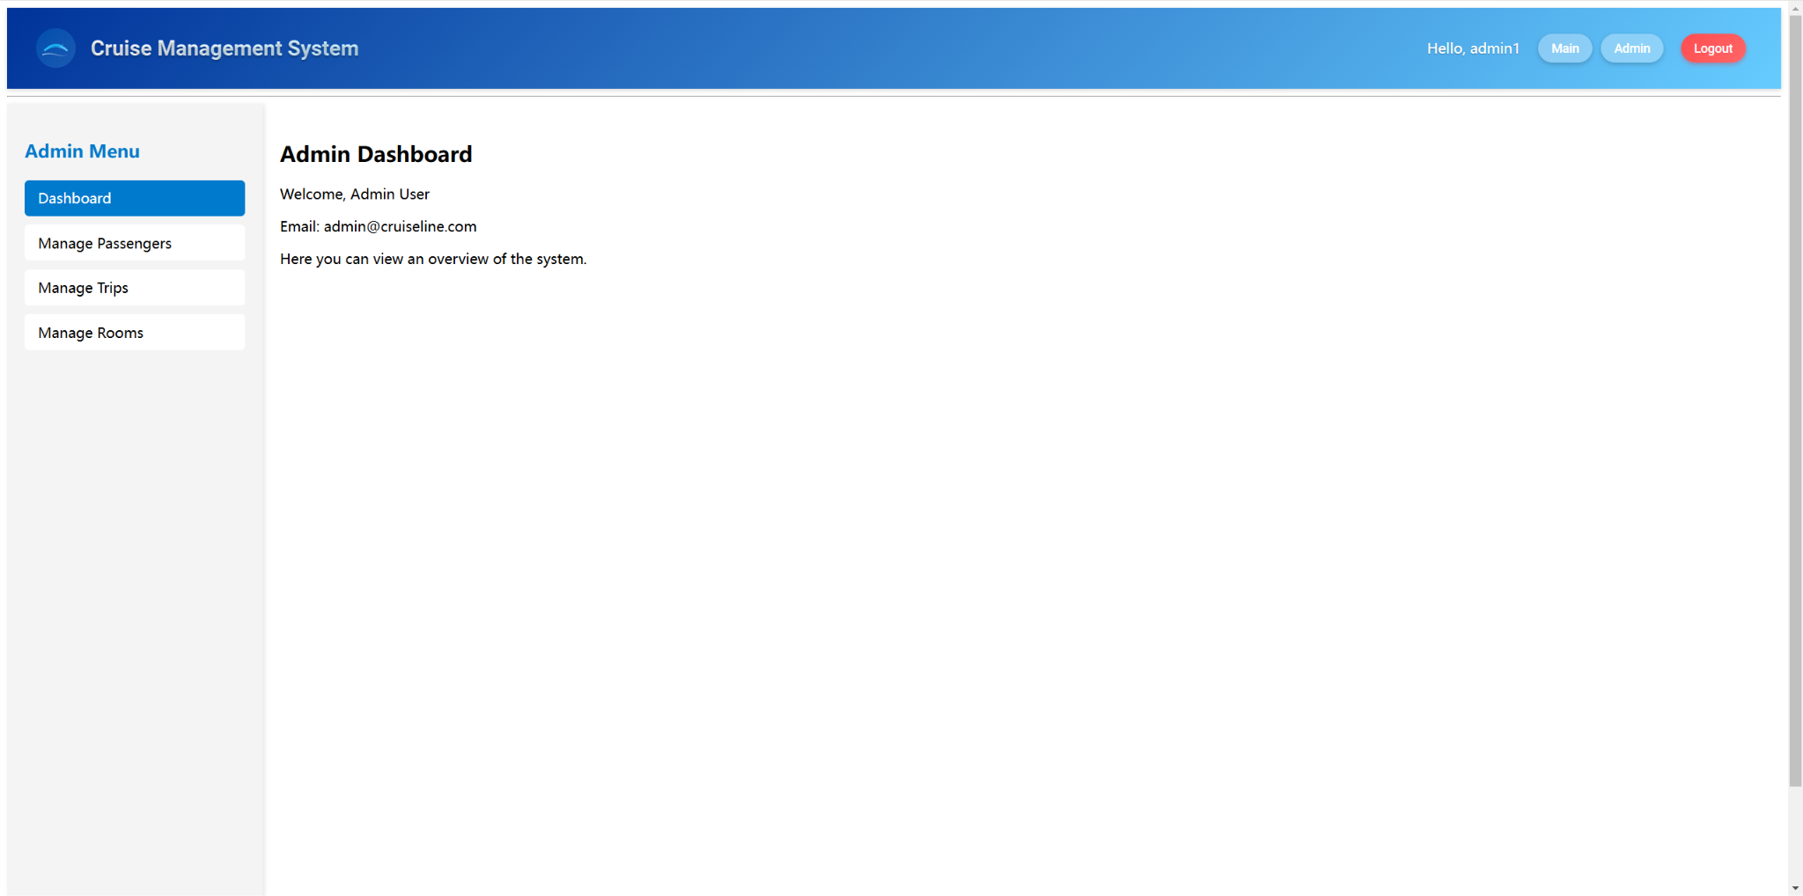
By clicking on Manage Rooms, the administrator can view and edit staterooms and prices.
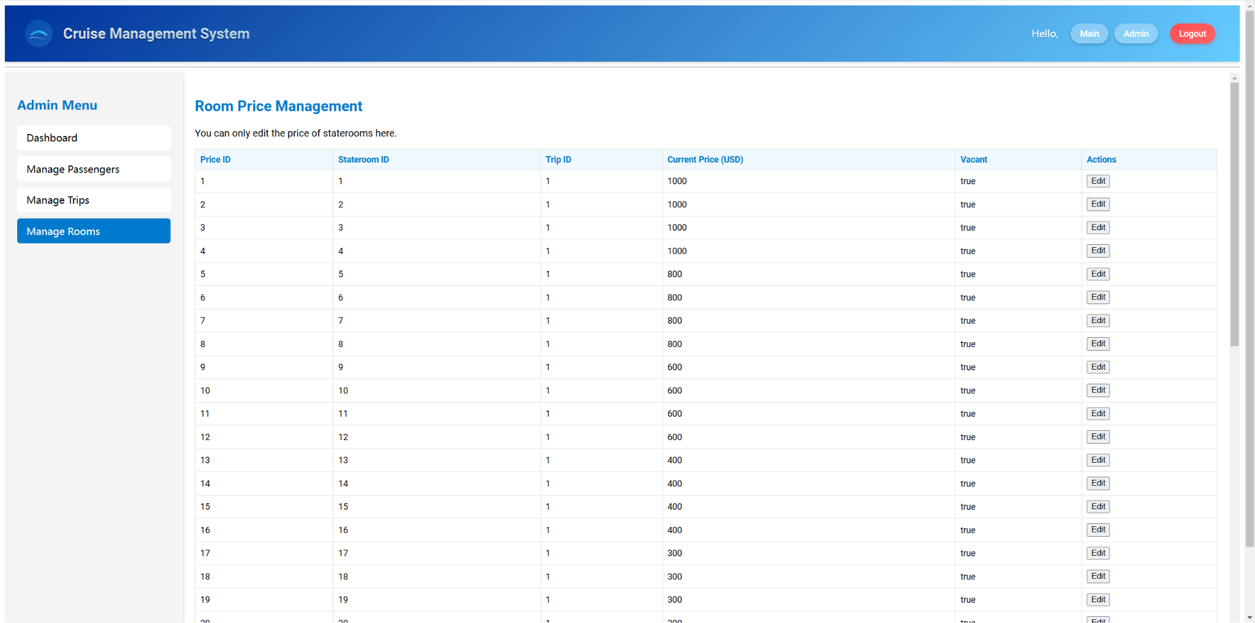

Security Features
- Database ORM: SQLAlchemy ORM is used, minimizing the risk of SQL injection compared to raw SQL queries.
- Input Sanitization: The sanitize_input function is used throughout to clean user-provided data, reducing the risk of XSS (Cross-Site Scripting) and injection attacks.
- Password Hashing: User passwords are hashed with werkzeug.security.generate_password_hash using a strong hashing algorithm (pbkdf2:sha256).
- Session Management for Access Control: Session variables are used to manage user sessions, including the user_id and user_type. Role-based access control is implemented (e.g., user_type == 'admin'), ensuring certain pages are accessible only to admins.
- CORS Configuration: CORS is restricted to specific origins (http://localhost:5173), which helps limit where requests can originate
- Error Handling and Rollbacks: Transactions are rolled back in case of errors, preventing partial commits that could lead to inconsistent data.

Lesson Learned
Reflecting on the project, several key lessons and insights emerged throughout the process:
Through this project, we gained hands-on experience with full-stack development, including database modeling using Data Modeler and implementing APIs with Flask. We also deepened our understanding of front-end frameworks like Vue.js and tools like Vite.
Collaborating with team members reinforced the importance of effective communication and role delegation to ensure progress and alignment.
Debugging front-end and back-end issues improved my ability to analyze errors systematically and find efficient solutions.
What Went Well
Despite challenges, our team maintained regular communication and worked collaboratively to meet deadlines. Tools like GitHub and Postman streamlined version control and API testing, improving development efficiency. The logical and relational models were designed effectively, accommodating the project's complex requirements.
What Did Not Go Well
Balancing this project with other academic commitments proved challenging, leading to tight deadlines and rushed phases of work.
Working remotely posed difficulties in syncing schedules and ensuring all team members were on the same page.
Communicating about API structures was sometimes unclear, leading to misunderstandings and additional time spent on building and testing functions.
Some debugging tasks were time-consuming, particularly when integrating the front-end and back-end components.

Business analysis
Since we use SQLite, the queries below will be in SQLite:

Q1) Table joins with at least 3 tables in join

A1) Select query
SELECT
t.trip_id AS TripID,
t.start_date AS StartDate,
t.end_date AS EndDate,
p.port_name AS PortName,
a.city AS City,
a.state_province AS StateProvince,
a.country AS Country
FROM
cyz_trip t
JOIN cyz_port p ON t.start_port_id = p.port_id OR t.end_port_id = p.port_id
JOIN cyz_address a ON p.addr_id = a.addr_id
WHERE t.trip_id = 1
ORDER BY t.trip_id, p.port_name;

A2) Result of the query
1|1735707600|1736053200|Los Angeles Port|Los Angeles|CA|USA
1|1735707600|1736053200|Seattle Port|Seattle|WA|USA

A3) Business Purpose
This query helps identify the start and end ports a specific trip passes through, including their locations (city, state/province, and country). It helps customers understand the start and destination of a particular trip.

Q2) Multi-row subquery

A1) Select query
SELECT
p.passenger_id AS "Passenger ID",
p.passenger_fname AS "First Name",
p.passenger_lname AS "Last Name"
FROM cyz_passenger p
WHERE p.group_id IN (
SELECT group_id
FROM cyz_payment
WHERE pay_amount > (SELECT AVG(pay_amount) FROM cyz_payment)
);

A2) Result of the query
1|Jane|Doe
2|John|Smith
3|Alex|Taylor
4|Sophia|Brown

A3) Business Purpose
This query identifies those groups whose payment amount is greater than the amount of the average passenger group, helping decision-makers to come up with sale strategies.

Q3) Correlated subquery.

A1) Select query
SELECT
s.price_id AS "Price ID",
s.trip_id AS "Trip ID",
s.price_per_night AS "Price per Night"
FROM cyz_stateroom_price s
WHERE s.price_per_night > (
SELECT AVG(s2.price_per_night)
FROM cyz_stateroom_price s2
WHERE s2.trip_id = s.trip_id
);

A2) Result of the query
1|1|1000.0
2|1|1000.0
3|1|1000.0
4|1|1000.0
5|1|800.0
6|1|800.0
7|1|800.0
8|1|800.0
9|1|600.0
10|1|600.0
11|1|600.0
12|1|600.0
29|2|1000.0
30|2|1000.0
31|2|1000.0
32|2|1000.0
33|2|800.0
34|2|800.0
35|2|800.0
36|2|800.0
37|2|600.0
38|2|600.0
39|2|600.0
40|2|600.0

A3) Business Purpose
This query helps identify the staterooms with prices above average and may help optimize pricing strategies.

Q4) SET operator query.

A1) Select query
SELECT user_id, username, email, user_type
FROM cyz_user
WHERE user_type = 'admin'
UNION
SELECT user_id, username, email, user_type
FROM cyz_user
WHERE user_type = 'passenger'
ORDER BY user_type;

A2) Result of the query
1|admin1|admin123@email.com|admin
2|admin2|admin234@email.com|admin
3|passenger1|passenger1@email.com|passenger
4|passenger2|passenger2@email.com|passenger
5|passenger3|passenger3@email.com|passenger
6|passenger4|passenger4@email.com|passenger

A3) Business Purpose
This query lists every user including administrator and passenger, for a quick overview of all users in the systems.

Q5) Query with in-line view or WITH clause

A1) Select query
WITH group_payments AS (
SELECT
group_id AS GroupID,
SUM(pay_amount) AS TotalPayment
FROM cyz_payment
GROUP BY group_id
)
SELECT GroupID, TotalPayment
FROM group_payments
WHERE TotalPayment > 1000
ORDER BY TotalPayment DESC;

A2) Result of the query
1|1040.0

A3) Business Purpose
This query highlights groups that have made significant payments, enabling targeted customer engagement or promotions.

Q6) TOP-N/BOTTOM-N query

A1) Select query
SELECT price_id AS "Price ID",
trip_id AS "Trip ID",
price_per_night AS "Price per Night"
FROM cyz_stateroom_price
WHERE trip_id == 1
ORDER BY price_per_night ASC
LIMIT 10;

A2) Result of the query
25|1|150.0
26|1|150.0
27|1|150.0
28|1|150.0
21|1|200.0
22|1|200.0
23|1|200.0
24|1|200.0
17|1|300.0
18|1|300.0

A3) Business Purpose
This query helps customers and salespersons to quickly identify the most economical staterooms.

